# Project Name: Setting Up Jenkins Pipeline to Deploy Docker Swarm.

## GitHub Link:

## https://github.com/tamasjit/myjavaproject/tree/master/Phase%205/Phase-5_Practice_Project/q4_Setting_Up_Jenkins_Pipeline_to_Deploy_Docker_Swarm

## Output:

### Jenkins Dashboard:

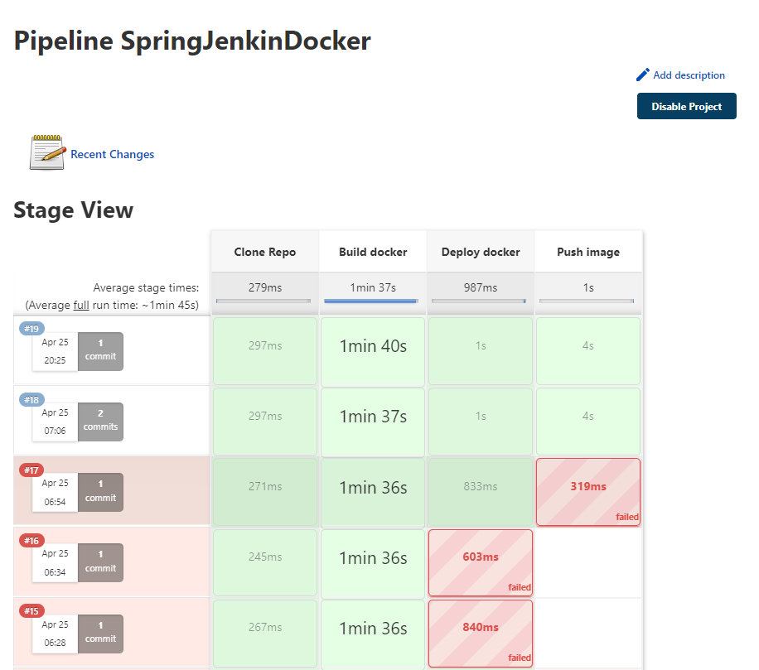

### Jenkins Console:

### User Data Editing:

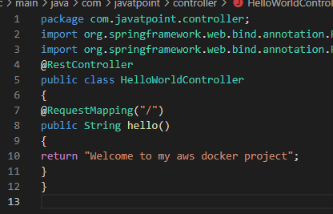

### Contact Form:

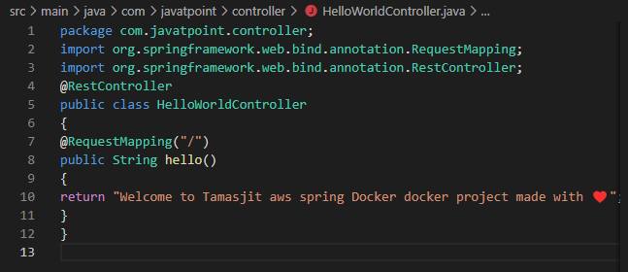

### Occurring changes after successful commit Automatically:

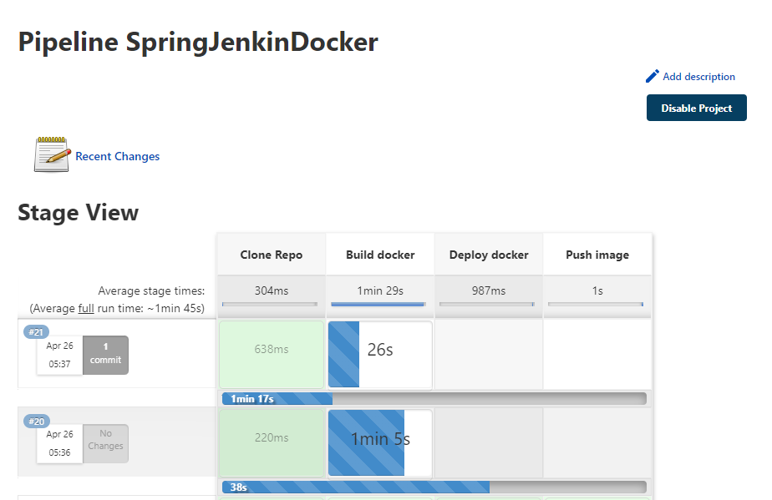

### Output on 8081 Port:

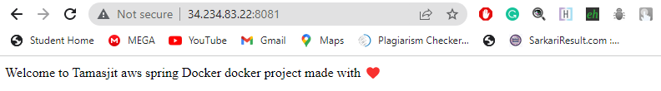

### Blue Ocean View:

